***Optimizing Credit Card Fraud Detection: The Power of Hyperparameter Tuning***

The rise of digital transactions and electronic payments has brought unprecedented convenience to the modern world. However, with this convenience comes the challenge of combating fraudulent activities in the financial sector, particularly in credit card transactions.

Credit card fraud is a pervasive issue that affects both financial institutions and cardholders, leading to substantial monetary losses and undermining trust in the financial system.

In light of these challenges, I am made this Credit Card Fraud Detection project, which serves as the focus of my internship. This project aims to develop a robust and accurate fraud detection system that can identify potentially fraudulent credit card transactions in real-time.

By leveraging advanced machine learning techniques, I intend to create a solution that not only detects fraud but also minimizes false positives, ensuring a seamless experience for legitimate cardholders.

This article is about this project of mine and the insights I gained during it.

***1. Introduction***

The surge in digital transactions has undoubtedly brought convenience to the modern world, but it has also given rise to the persistent challenge of credit card fraud. In response to this, machine learning models have become instrumental in real-time fraud detection. This article delves into the pivotal role of hyperparameter tuning, exploring its significance in fine-tuning machine learning algorithms for effective credit card fraud detection.

***2. Technology and Concepts:***

**2.1 Machine Learning:**

* + Machine learning is a method of data analysis that automates analytical model building.
  + It is a branch of artificial intelligence based on the idea that systems can learn from data, identify patterns and make decisions with minimal human intervention.
* It automates tasks, enhances decision-making, and enables personalization.
  + Machine Learning algorithm learns from experience E with respect to some type of task T and performance measure P, if its performance at tasks in T, as measured by P, improves with experience E.
  + It enables computers to learn and improve from experience without explicit programming.
  + ML models make predictions or decisions based on data patterns.

It can be used in two ways:

* + 1. ***Supervised Learning***

Supervised learning is a machine learning paradigm where an algorithm is trained on labeled data, learning to make predictions or classify inputs based on past examples provided in the training set.

* + 1. ***Unsupervised Learning***

Unsupervised learning is a machine learning approach where algorithms analyze

unlabeled data to discover hidden patterns, clusters, or structures without

explicit guidance from predefined outcomes or labels.

* 1. **Random Forest Algorithm**
* A Random Forest is a powerful ensemble learning technique in machine learning.
* It combines multiple decision trees, each trained on a random subset of the training data, and aggregates their predictions to make more accurate and robust predictions.
* This ensemble approach helps mitigate overfitting, resulting in a more generalized model.
* They also handle missing data and outliers well, making them robust in real-world scenarios.
* Additionally, Random Forests provide a feature importance ranking, helping users identify the most influential features in their data.
* Due to their reliability and effectiveness, Random Forests are widely used in various domains, from finance to healthcare and beyond.

***3***. ***Methodology:***

The project involved developing a Streamlit web application for credit card fraud detection, encompassing all steps of the machine learning pipeline.

**3.1 The process of Machine learning:**



*Fig 3.1: Machine learning process (*[*source*](https://medium.com/analytics-vidhya/data-science-process-flow-and-machine-learning-fundamentals-6da8c591e8af)*)*

**3.1.1 Data Preprocessing:**

Preparing and preprocessing the dataset to ensure it is suitable for training and testing machine learning models. This involves tasks such as data cleaning, feature engineering, and handling class imbalance.

**3.1.1.1 Importing Dataset:**

The First part is importing dataset.

**3.1.1.2 Seeing the Missing Data:**

The next part is seeing that this dataset does not contain missing data.

**3.1.1.3 Seeing the Dataset Distribution:**

The next observation is a huge class imbalance in this dataset so for this we extracted data for both the classes and then we are going to create a new dataframe which will contain equal distribution and then this will serve as the data for our model.

**3.1.1.4 Balancing the Dataset Class Distribution:**

Now in the updated dataframe we have equal number of both Fraud and Not Fraud data and this will help avoid overfitting. This dataframe is saved as csv file which is the dataset for our model.

**3.1.2 Feature Extraction:**

Now our text target is to find the Features for Input and Output in the model.

Now we have extracted features for input and output and also splitted testing and training data. After Splitting into training and testing data, to ensure compatibility we also convert to numpy contiguous array to ensure stability and compatibility with scikit-learn functions. The next task is model development or choosing algorithm.

**3.1.3 Model/Algorithm Development:**

**3.1.3.1 Exploratory Data Analysis:**

* After feature extraction several supervised learning algorithm are applied in this dataset and the highest accuracy is given by random forest algorithm.
* Thus Random Forest algorithm works best for this dataset.

**3.1.3.2 Hyperparameter Tuning:**

* Hyperparameter tuning is the process of optimizing the settings or configuration of a machine learning model to enhance its performance.
* This involves systematically adjusting hyperparameters, such as learning rates, regularization strengths, and tree depths, through techniques like grid search or random search to find the best combination that yields the highest accuracy or minimizes the loss function.
* Hyperparameter tuning is essential for fine-tuning model behavior and achieving optimal results in various machine learning tasks.
* In this project I have created a streamlit app in which we can see the performance of supervised learning algorithms in this dataset and also tune parameters and see the effect on overall accuracy.

**3.1.3 Model/Algorithm Testing:**

Finally we check the training and testing accuracy for our model for all datasets.

***4. Result and Discussion***

Results from both localhost and Streamlit outputs are presented in this section. The discussion revolves around the implications of these results for credit card fraud detection, emphasizing the delicate balance required to achieve high accuracy while minimizing false positives.

**4.1.1 Streamlit Server:**

After visiting the link we can see the output as follows on the browser:

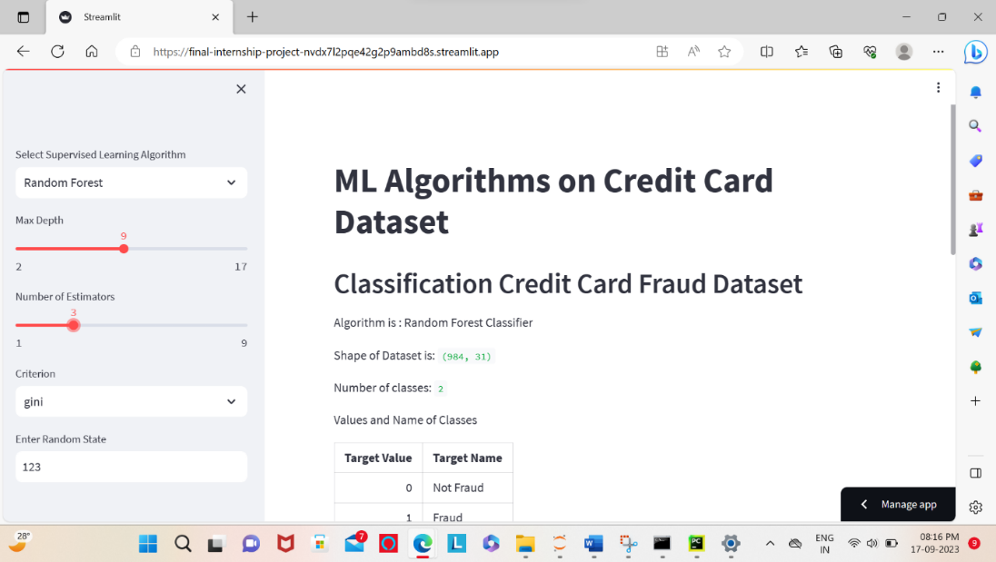

*Fig 4.1.1.1: Streamlit Output 1*

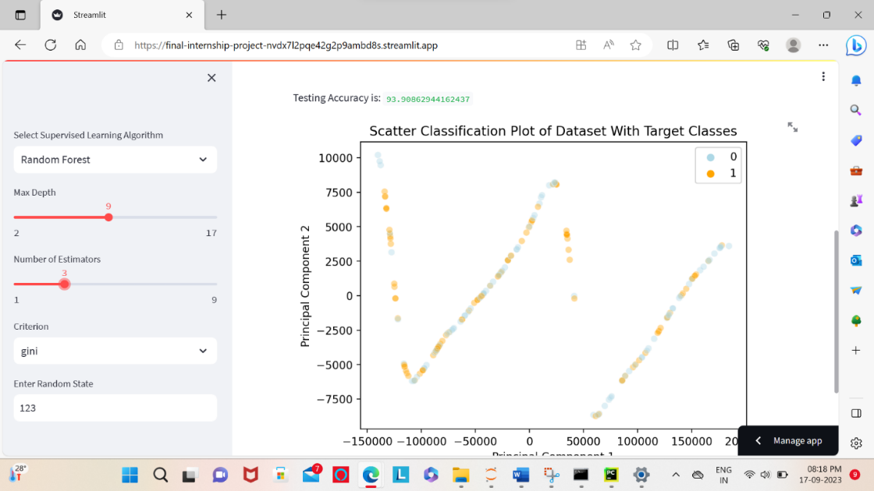

*Fig 4.1.1.2: Streamlit Output 2*

***5.*** ***Future Enhancements***

Looking ahead, this explores potential future enhancements to further elevate the credit card fraud detection system. Suggestions include the integration of deep learning, anomaly detection techniques, continuous monitoring, and ethical considerations. The adaptive nature of fraud detection is underscored, emphasizing the need for ongoing improvements.

***6. Conclusion***

The application's user-friendly design caters to experts and non-technical users, facilitating data-driven decision-making. Meticulous data preprocessing, feature engineering, and hyperparameter tuning laid the foundation for robust machine learning models. Deploying the application ensures practical utility, showcasing the synergy between machine learning and user-friendly interfaces for effective data exploration and knowledge dissemination.

This article serves as a comprehensive guide to hyperparameter tuning in credit card fraud detection, offering practical insights and recommendations for optimizing machine learning models in a real-world context.